CAUVERY COLLEGE FOR WOMEN (AUTONOMOUS), TRICHY-18
SWAYAM NPTEL - ONLINE COURSE
MERIT STUDENTS LIST
June 2021 - May 2022

NUMBER OF STUDENTS CLEARED: 1559
TOPPER: 3
ELITE + GOLD: 19
ELITE + SILVER: 85
ELITE: 371
SUCCESSFULLY COMPLETED: 1081

NAME | DEPARTMENT | COURSE | GRADE
R.ABARNA | I M.Sc MB | Forest and their Management | Elite + Gold with Topper
S. SHARMILA DEVI | II B.Sc MB | Forest and their Management | Elite + Gold with Topper
R.NANDHINI | II B.Sc Chemistry | Bioinorganic Chemistry | Elite + Gold with Topper
ABINAYA S | I B.Sc MB | Maternal Infant Young Child Nutrition | Elite + Gold
DEVADHARSHINI P | I B.Sc MB | Maternal Infant Young Child Nutrition | Elite + Gold
NAGAJOTHI M | I B.Sc MB | Maternal Infant Young Child Nutrition | Elite + Gold
TASNEEMA ABDUL KUTHUZ | I B.Sc MB | Maternal Infant Young Child Nutrition | Elite + Gold
ANISHA.K | II B.Sc MB | Forest and their Management | Elite + Gold
ARTHI.K | II B.Sc MB | Forest and their Management | Elite + Gold
POOJASREE.S.M | II B.Sc MB | Forest and their Management | Elite + Gold
P. SRIDHARSHINI | II B.Sc MB | Forest and their Management | Elite + Gold
R.P.CHARUMATHI | I M.Sc MB | Forest and their Management | Elite + Gold
A.JANANI | I M.Sc MB | Forest and their Management | Elite + Gold
S.MADHUMITHA | I M.Sc MB | Forest and their Management | Elite + Gold
S.NAZEERA BEGUM | I M.Sc MB | Forest and their Management | Elite + Gold
K.SELVAPRIYA | I M.Sc MB | Forest and their Management | Elite + Gold
N.THASHMINA | I M.Sc MB | Forest and their Management | Elite + Gold
DEVI BALA S | I M.Sc FSM | Maternal Infant Young Child Nutrition | Elite + Gold
GAYATHRI K | I M.Sc FSM | Maternal Infant Young Child Nutrition | Elite + Gold
GEETHA M | I M.Sc FSM | Maternal Infant Young Child Nutrition | Elite + Gold
SHANMUGA SUNDARI M | I M.Sc FSM | Maternal Infant Young Child Nutrition | Elite + Gold
THANGASHALINI S | I M.Sc FSM | Maternal Infant Young Child Nutrition | Elite + Gold

ELITE + GOLD with TOPPER

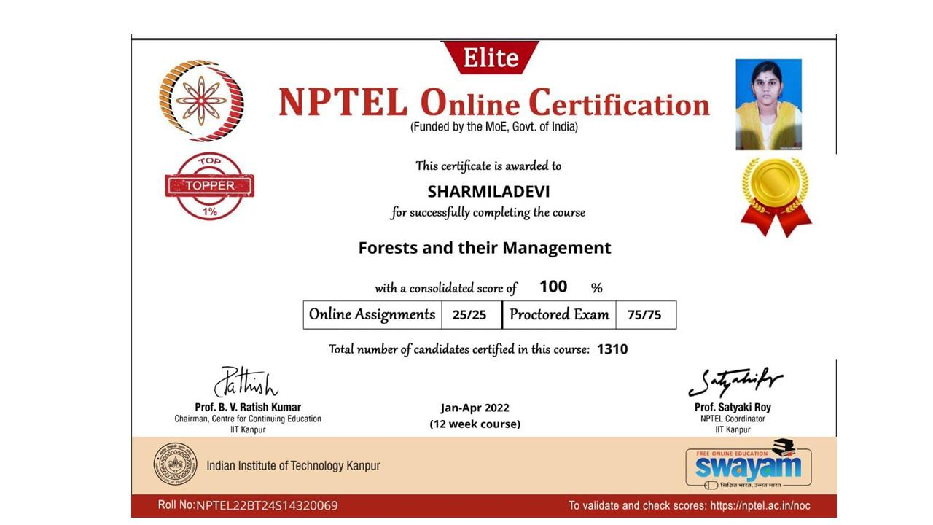

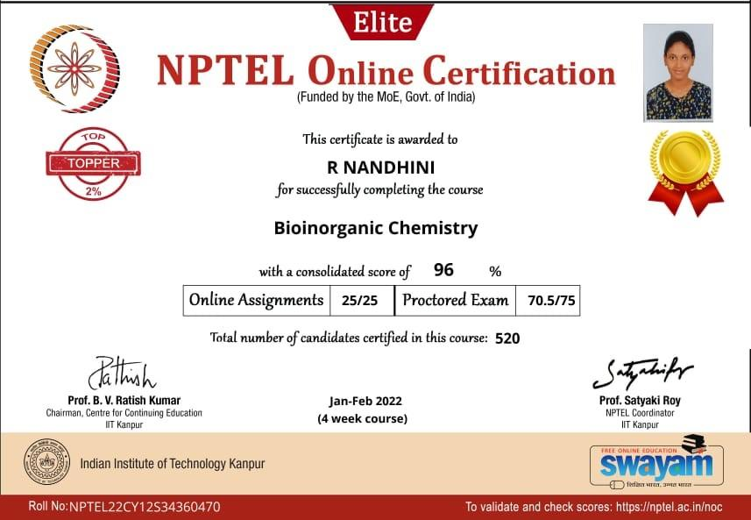

ELITE + GOLD

