CAUVERY COLLEGE FOR WOMEN (AUTONOMOUS), TRICHY-18
SWAYAM NPTEL - ONLINE COURSE
MERIT STUDENTS LIST
June 2020 - May 2021

NUMBER OF STUDENTS CLEARED: 1490
ELITE + GOLD TOPPER: 03
ELITE + SILVER TOPPER: 05
ELITE + GOLD: 03
ELITE + SILVER: 76
ELITE: 491
SUCCESSFULLY COMPLETED: 912

NAME | DEPARTMENT | COURSE | GRADE
Ms. Ashwini B | Commerce | Body language: Key to professional Success | Elite + Gold with Topper
Ms. S. Harini | Commerce | Body language: Key to professional Success | Elite + Gold with Topper
Dhanuja. K | Biotechnology | Human Behaviour | Elite + Gold with Topper
Pavithra | Biotechnology | Human Behaviour | Elite + Silver with Topper
Mohanapriya M | Chemistry | Basics in Inorganic Chemistry | Elite + Silver with Topper
Ashwini B | Commerce | Speaking Effectively | Elite + Silver with Topper
Mathumitha. M | Food Service Management & Dietetics | Effective Writing | Elite + Silver with Topper
Swethavarshini. G | English | Effective Writing | Elite + Silver with Topper
Kiruthikaa. P | Food Service Management & Dietetics | Employment Communication A Lab based course language: Key to professional Success | Elite + Gold
K Nikitha | Food Service Management & Dietetics | Employment Communication A Lab based course language: Key to professional Success | Elite + Gold
Sharfunnisa SH | Food Service Management & Dietetics | Employment Communication A Lab based course language: Key to professional Success | Elite + Gold

ELITE + GOLD with TOPPER

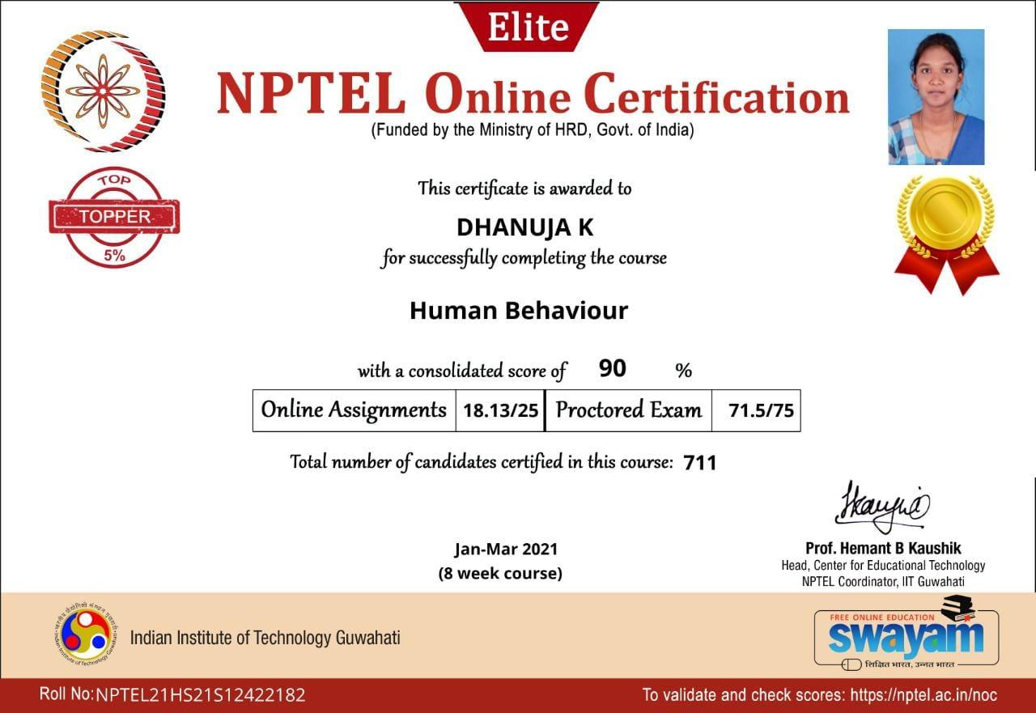

ELITE + SILVER with TOPPER
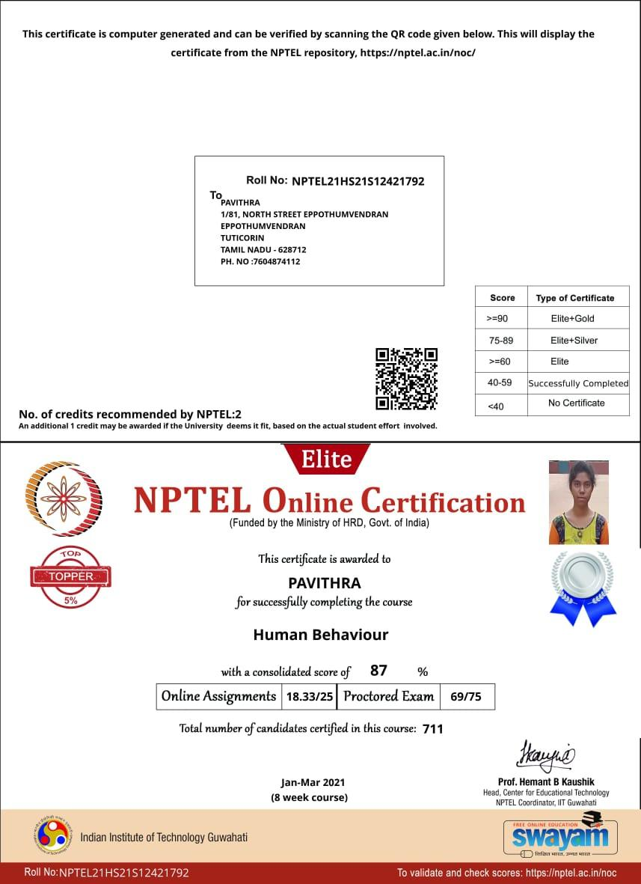

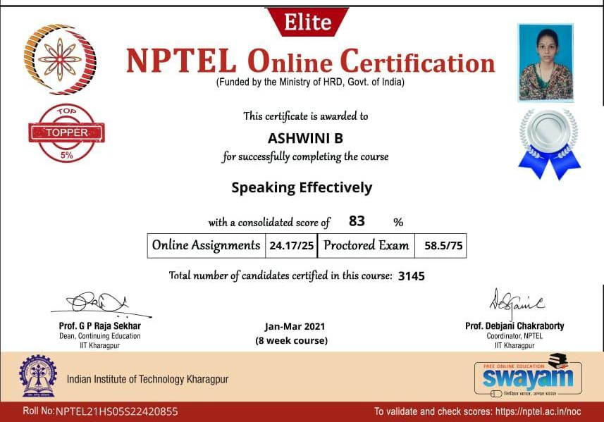

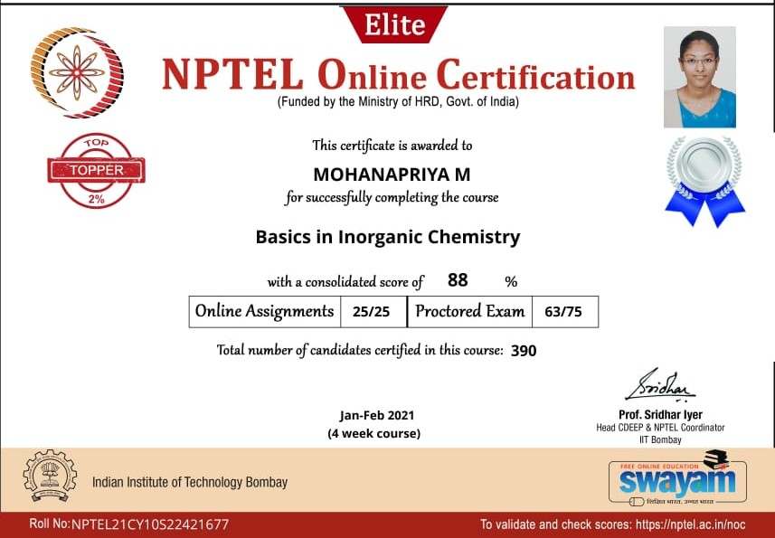

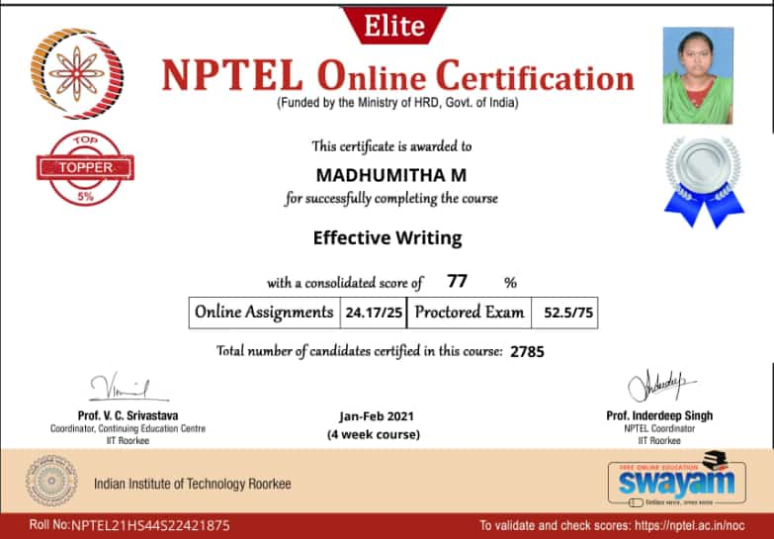

ELITE + GOLD

