CAUVERY COLLEGE FOR WOMEN (AUTONOMOUS), TRICHY-18
SWAYAM NPTEL - ONLINE COURSE - FACULTY LIST
June 2020 - May 2021

For the academic year 2020-2021 totally 41 faculty members were registered for the NPTEL course and 28 got certified.

ELITE + GOLD: 2
ELITE + SILVER: 8
ELITE: 8
SUCCESSFULLY COMPLETED: 10
NAME | DEPARTMENT | COURSE | GRADE
Dr. G. Mettilda Bhuvaneswari | SW | Enhancing Soft Skills and Personality Development | Elite + Gold
Dr. P. Sudha | Maths | Descriptive Statistics with R Software | Elite + Gold
Dr.M. Neela | BBA | Developing Soft Skills and Personality | Elite + Silver
Dr.M. Neela | BBA | Enhancing Soft Skills and Personality | Elite + Silver
Dr. M. Neela | BBA | Speaking Effectively | Elite + Silver
Dr. S. Jayashree Agarwal | English | The Psychology of Language | Elite + Silver
J. Aarthi | Physics | A Brief Course on Superconductivity | Elite + Silver
Dr. V. Sangu | Chemistry | Basic in inorganic | Elite + Silver
Ms. R. Soundaria | Mathematics | Descriptive Statistics with R Software | Elite + Silver
Ms. A. Gowri Shankari | Mathematics | Descriptive Statistics with R Software | Elite + Silver
Ms. S. Agalya | F.S.M | Body Language: Key to Professional Success | Elite
Ms. T. R. Revathi | F.S.M | Body Language: Key to Professional Success | Elite
Ms. R. Soundaria | Mathematics | Python for Data Science | Elite
Dr. K.Kalaiarasi | Mathematics | Descriptive Statistics with R Software | Elite
Ms. P. Sudha | Mathematics | Python for Data Science | Elite
Dr.K.Kannagi | Physics | A Brief Course on Superconductivity | Elite
Dr. S. Jeyabharathi | Microbiology | Waste to Energy Conversion | Elite
Ms. N. Jeenathunisa | Microbiology | Plastic Waste Management | Elite
V. Kavitha | C.Sc | Google Cloud Computing Foundations | Successfully Completed
Dr. K.Kalaiarasi | Mathematics | Graph Theory | Successfully Completed
Dr. K.Kalaiarasi | Mathematics | Probability and Statistics | Successfully Completed
Dr. K. Kalaiarasi | Mathematics | Computational Mathematics with SageMath | Successfully Completed
Dr. R. Buvaneswari | Mathematics | Computational Mathematics with SageMath | Successfully Completed
Ms. R. Soundaria | Mathematics | Essentials of Data Science with R Software - 1: Probability and Statistical Inference | Successfully Completed
Dr.K.Kannagi | Physics | Experimental Physics - I | Successfully Completed
B. Anitha | Physics | Experimental Physics - I | Successfully Completed
T. Noorunnisha | Physics | Experimental Physics - I | Successfully Completed
P.Ilamathy | Biotechnology | Organic Farming for Sustainable Agriculture Production | Successfully Completed

ELITE + GOLD

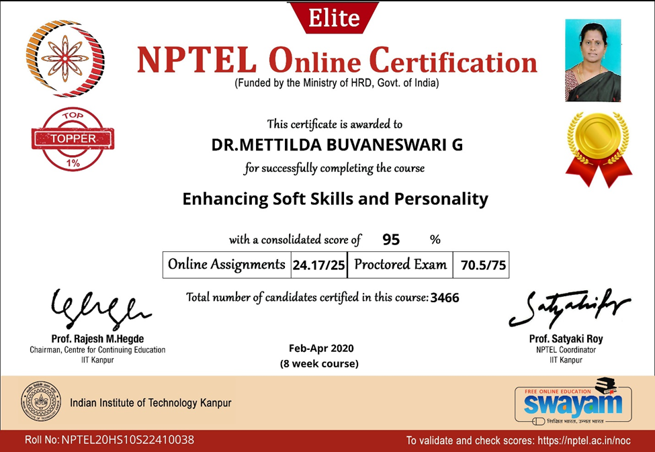

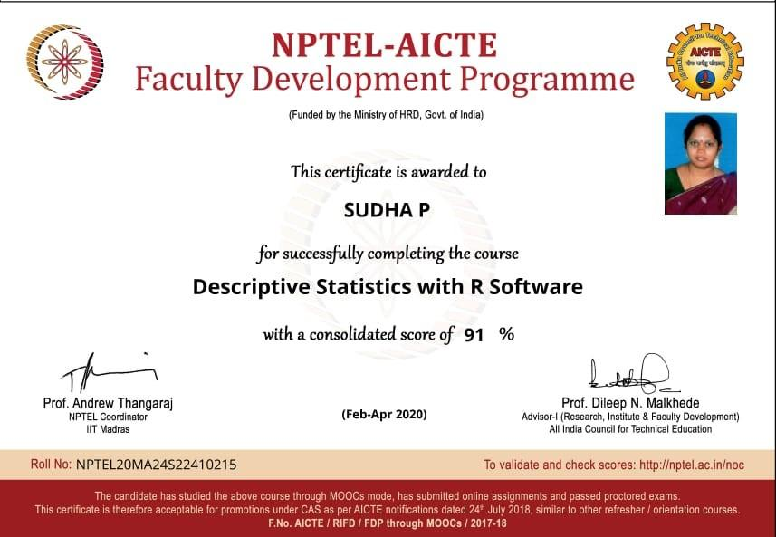

ELITE + SILVER

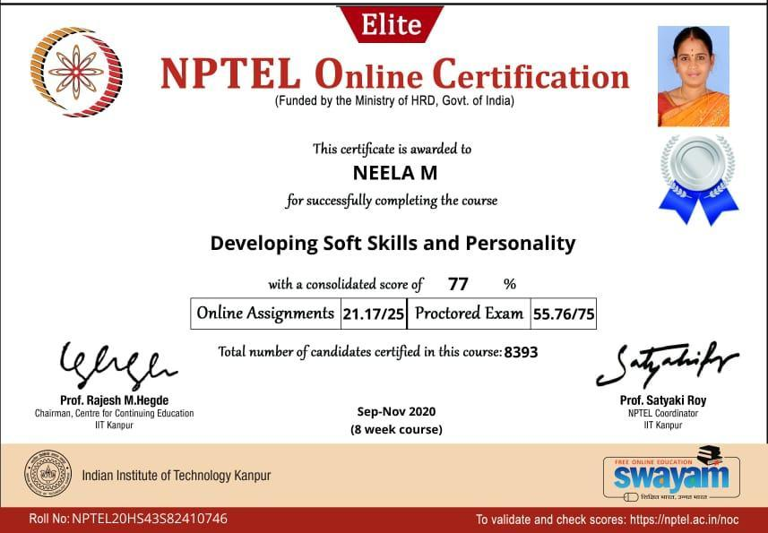

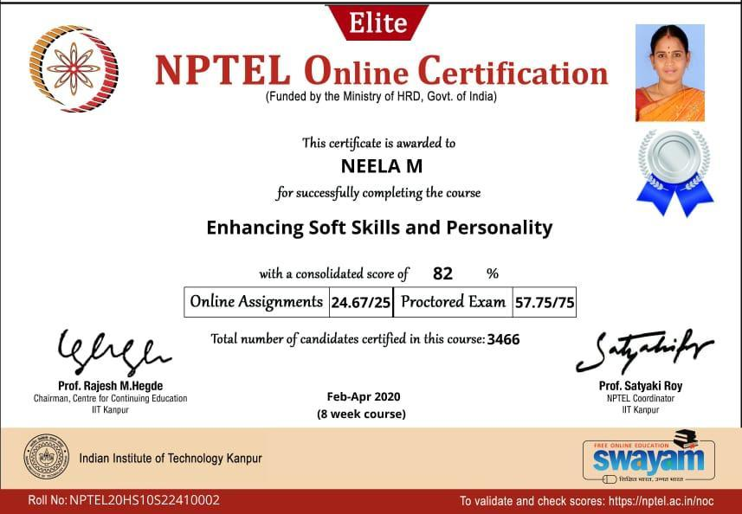

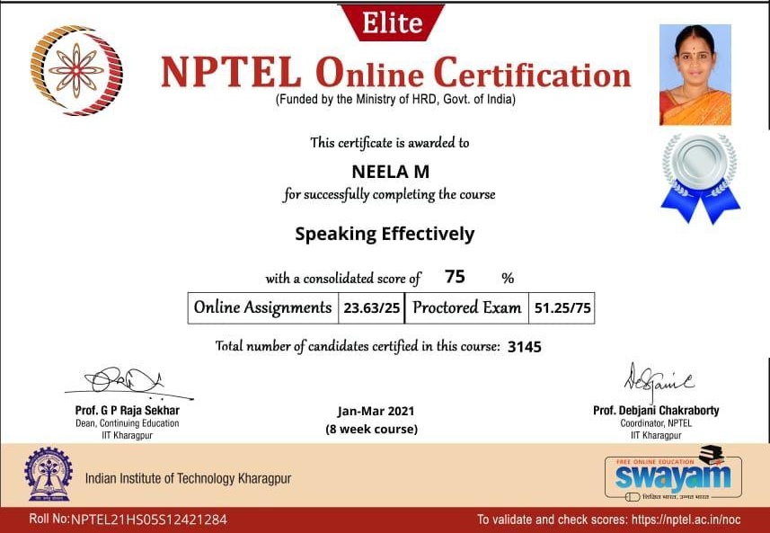

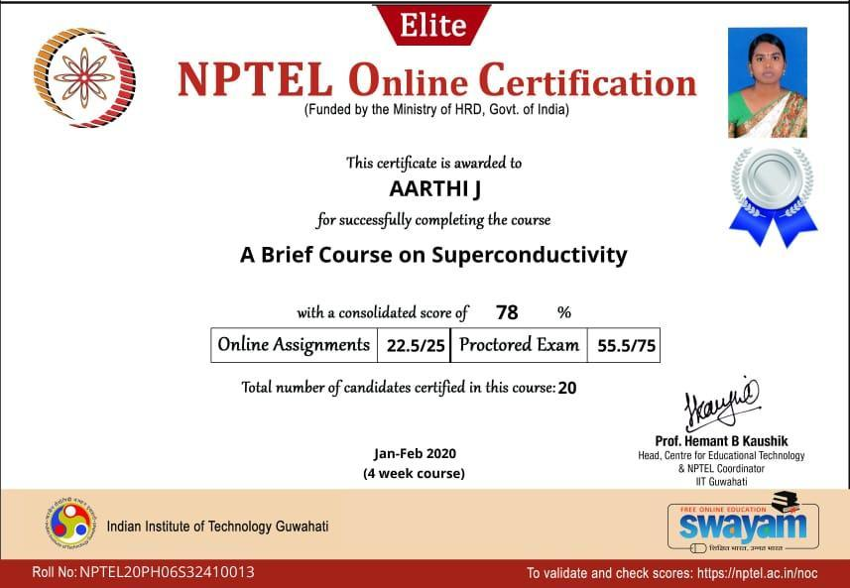

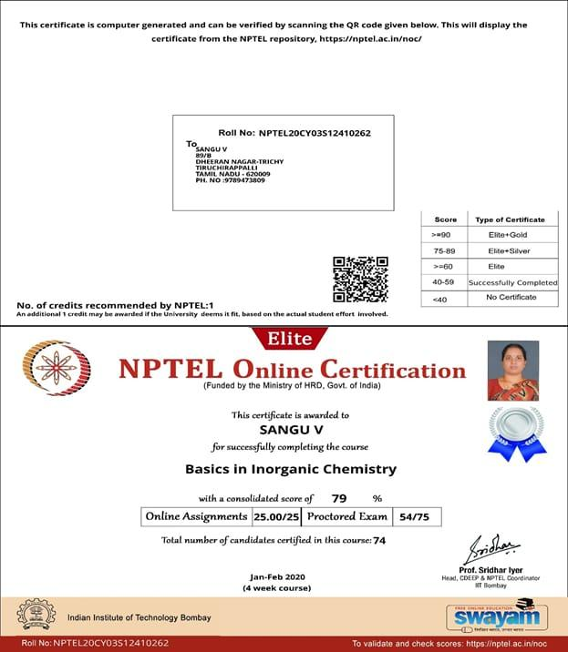

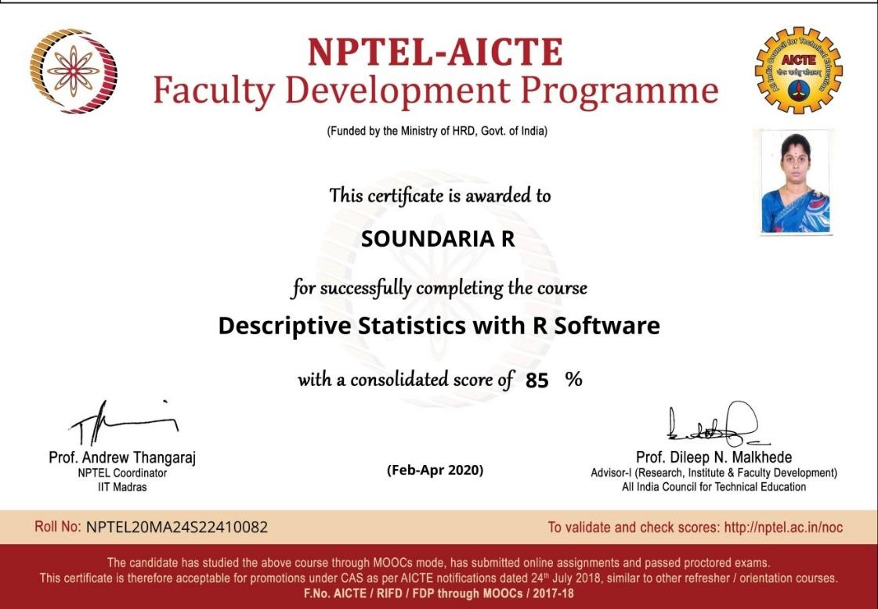

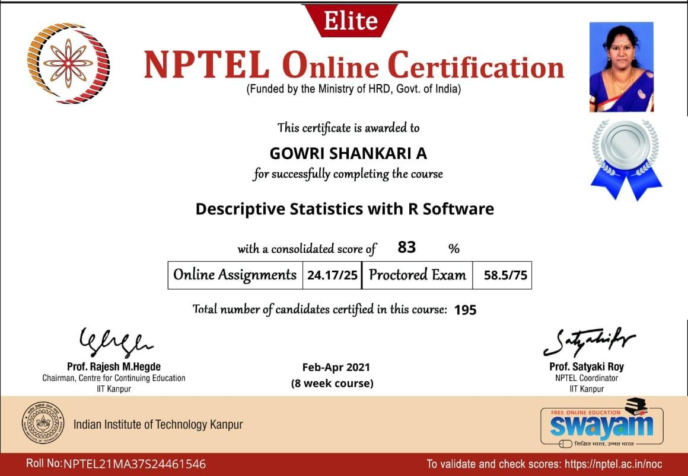

ELITE

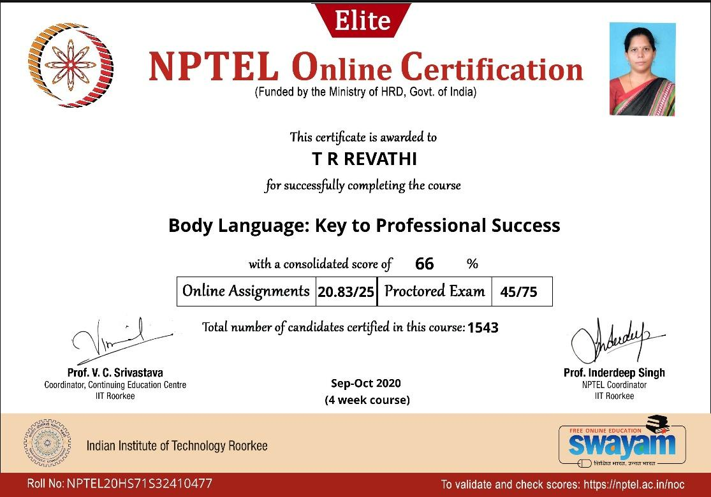

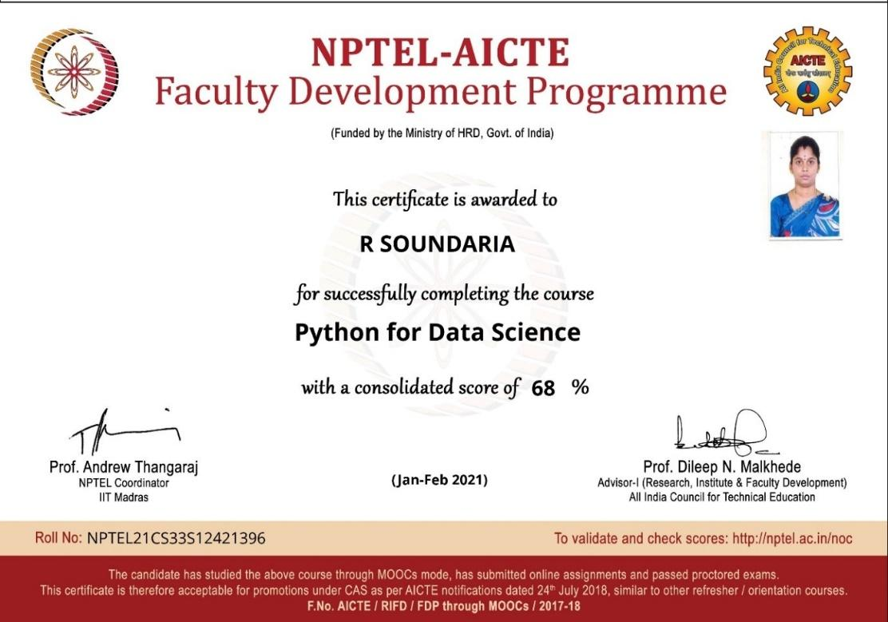

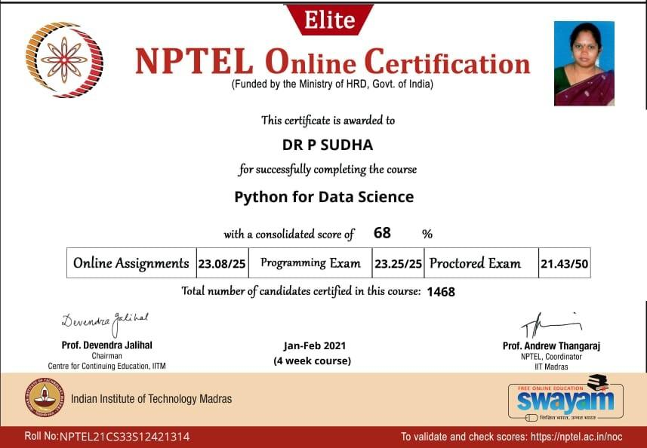

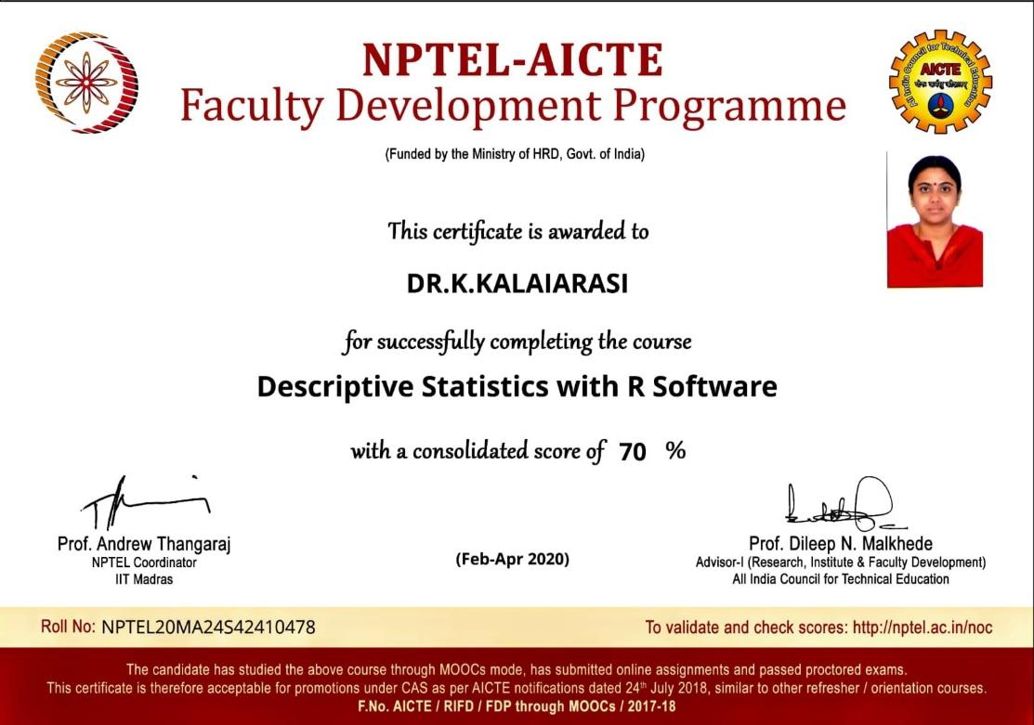

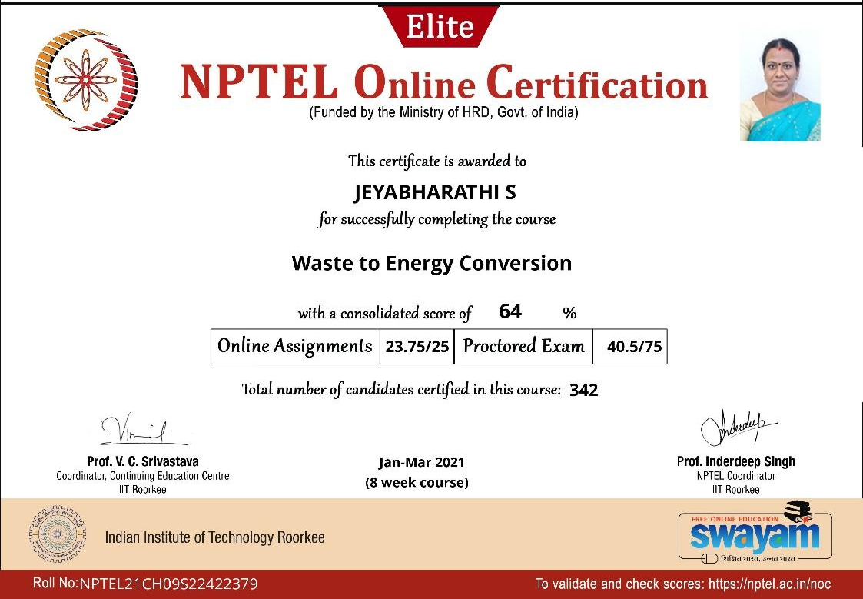

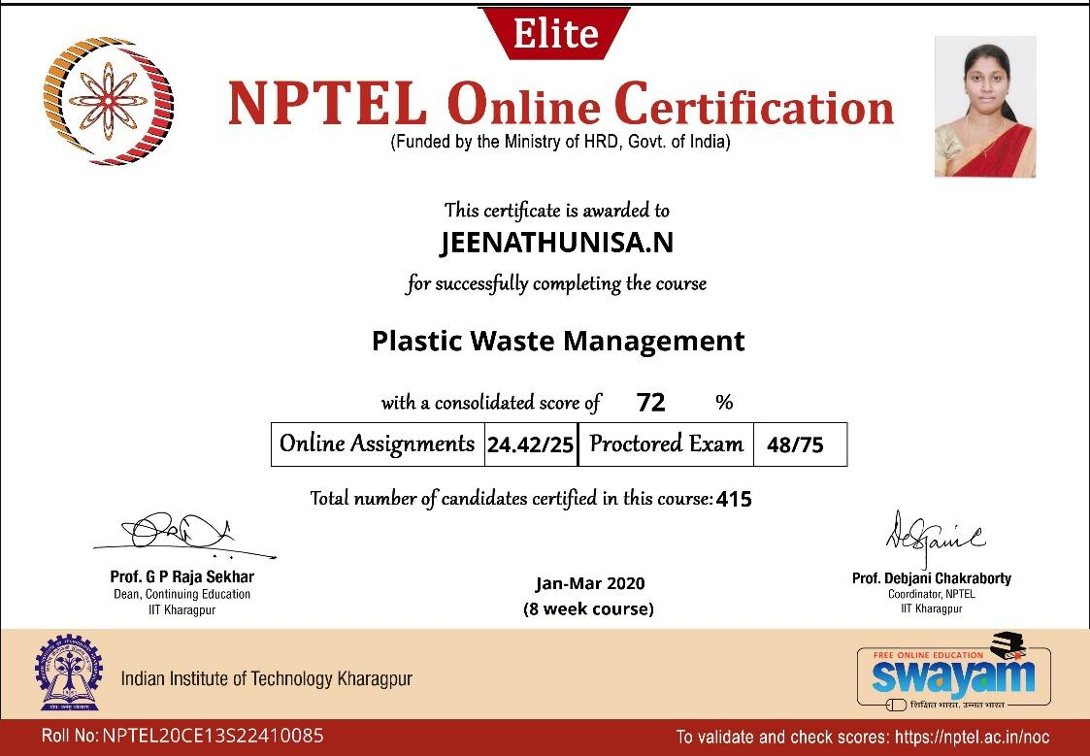

SUCCESSFULLY COMPLETED

